Lab6: REST full Api along with Spring Security assignment
Screen prints after executing Student Debate Event project

Security roles defined from the database tables:
Vani is User and Vani1 is Admin role
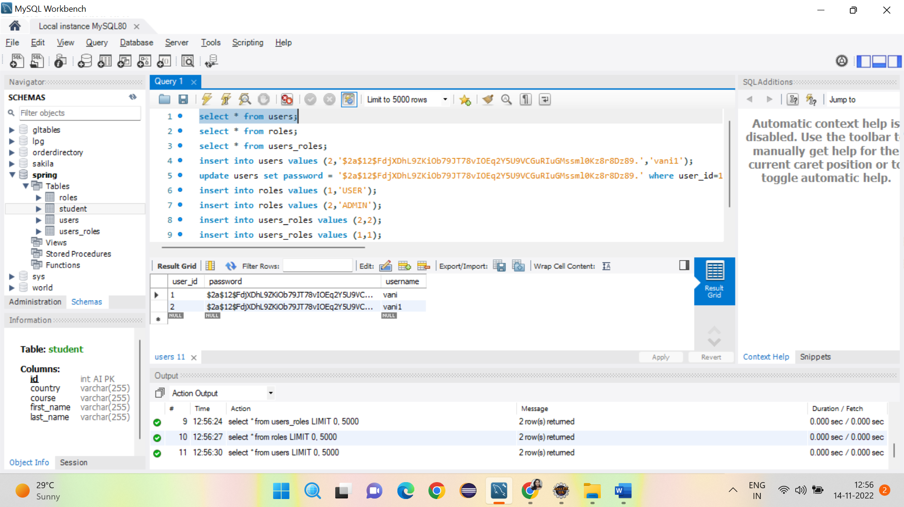

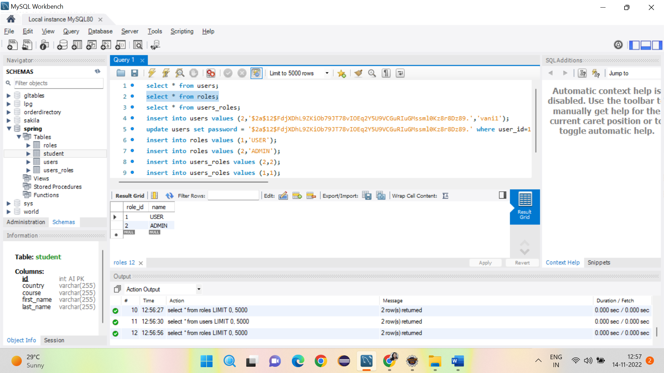

Very First page when hitting project page from local host /StudentEvent
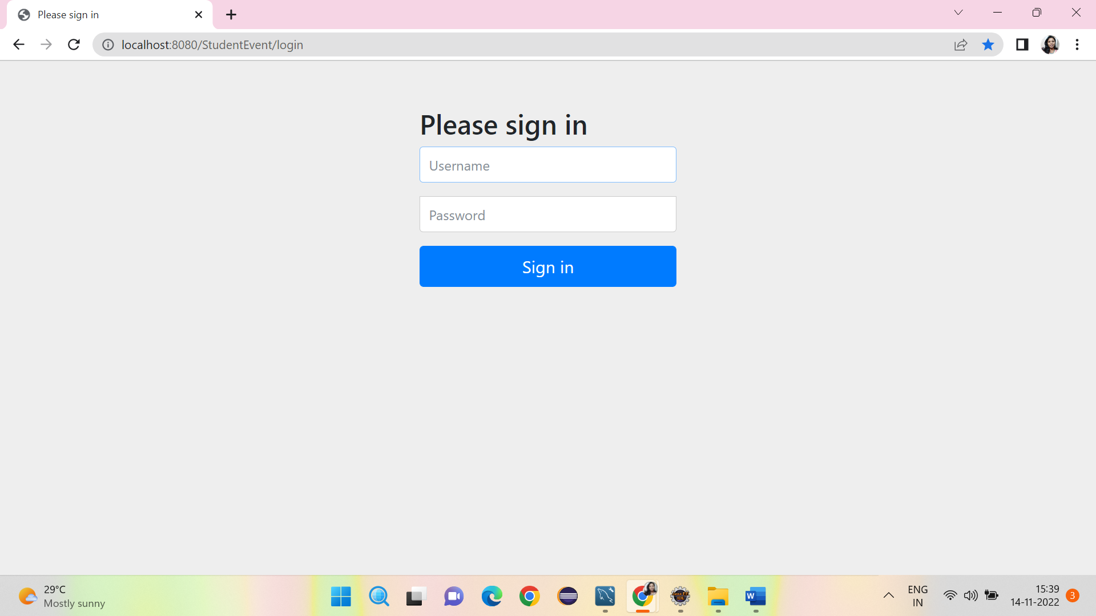

Logged in as admin , allowing to perform Update and delete all operations

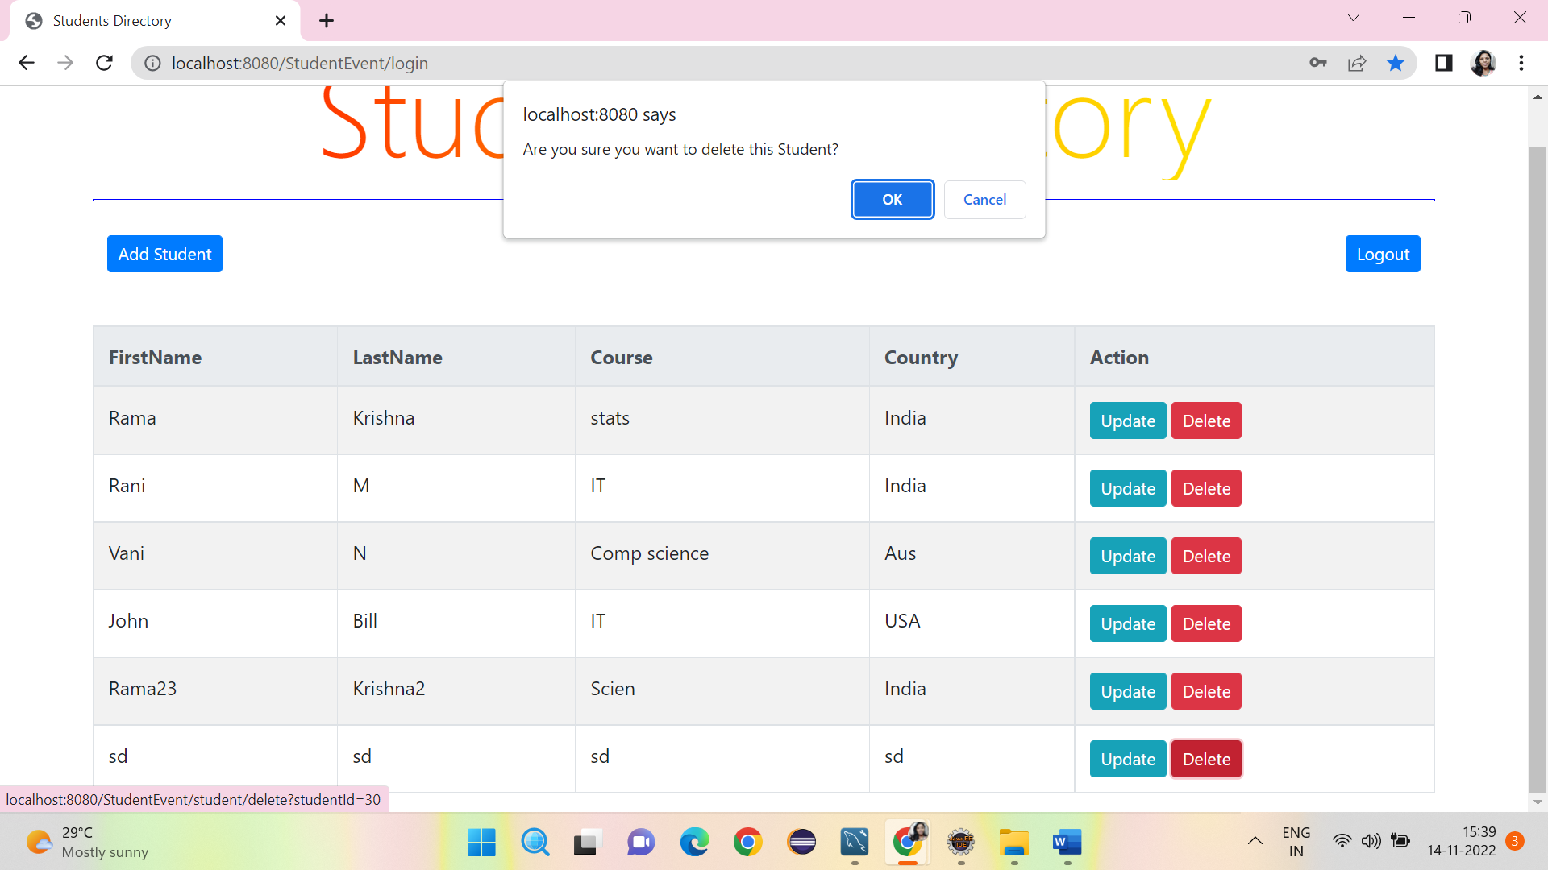
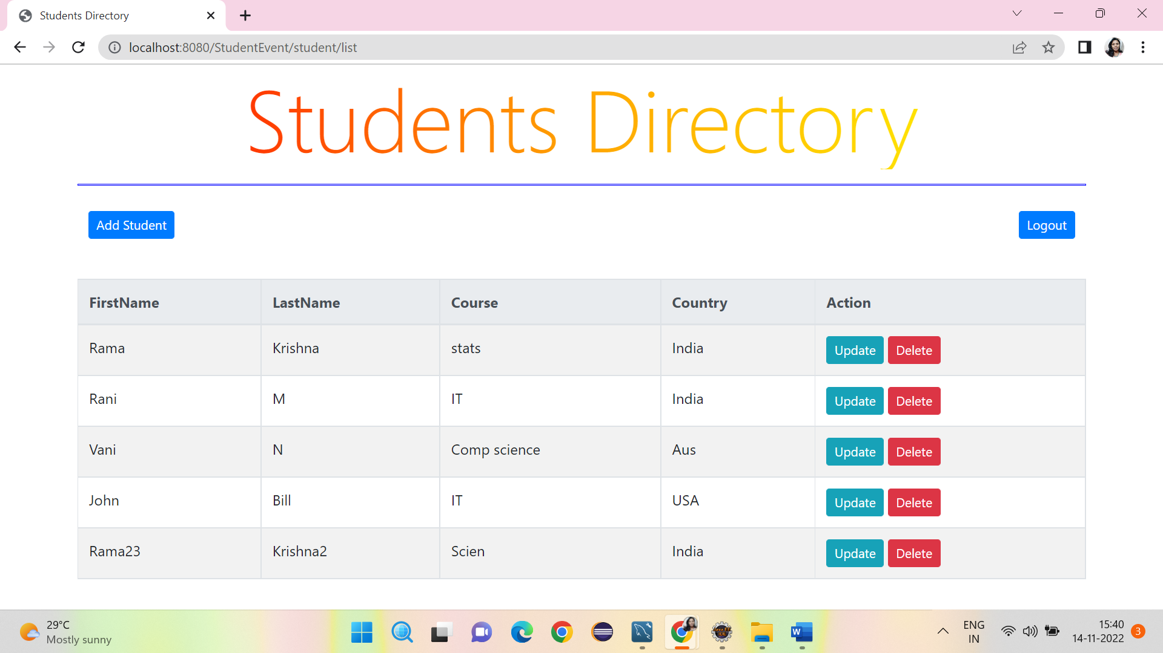

Logged in as user , not allowing me to perform delete or update
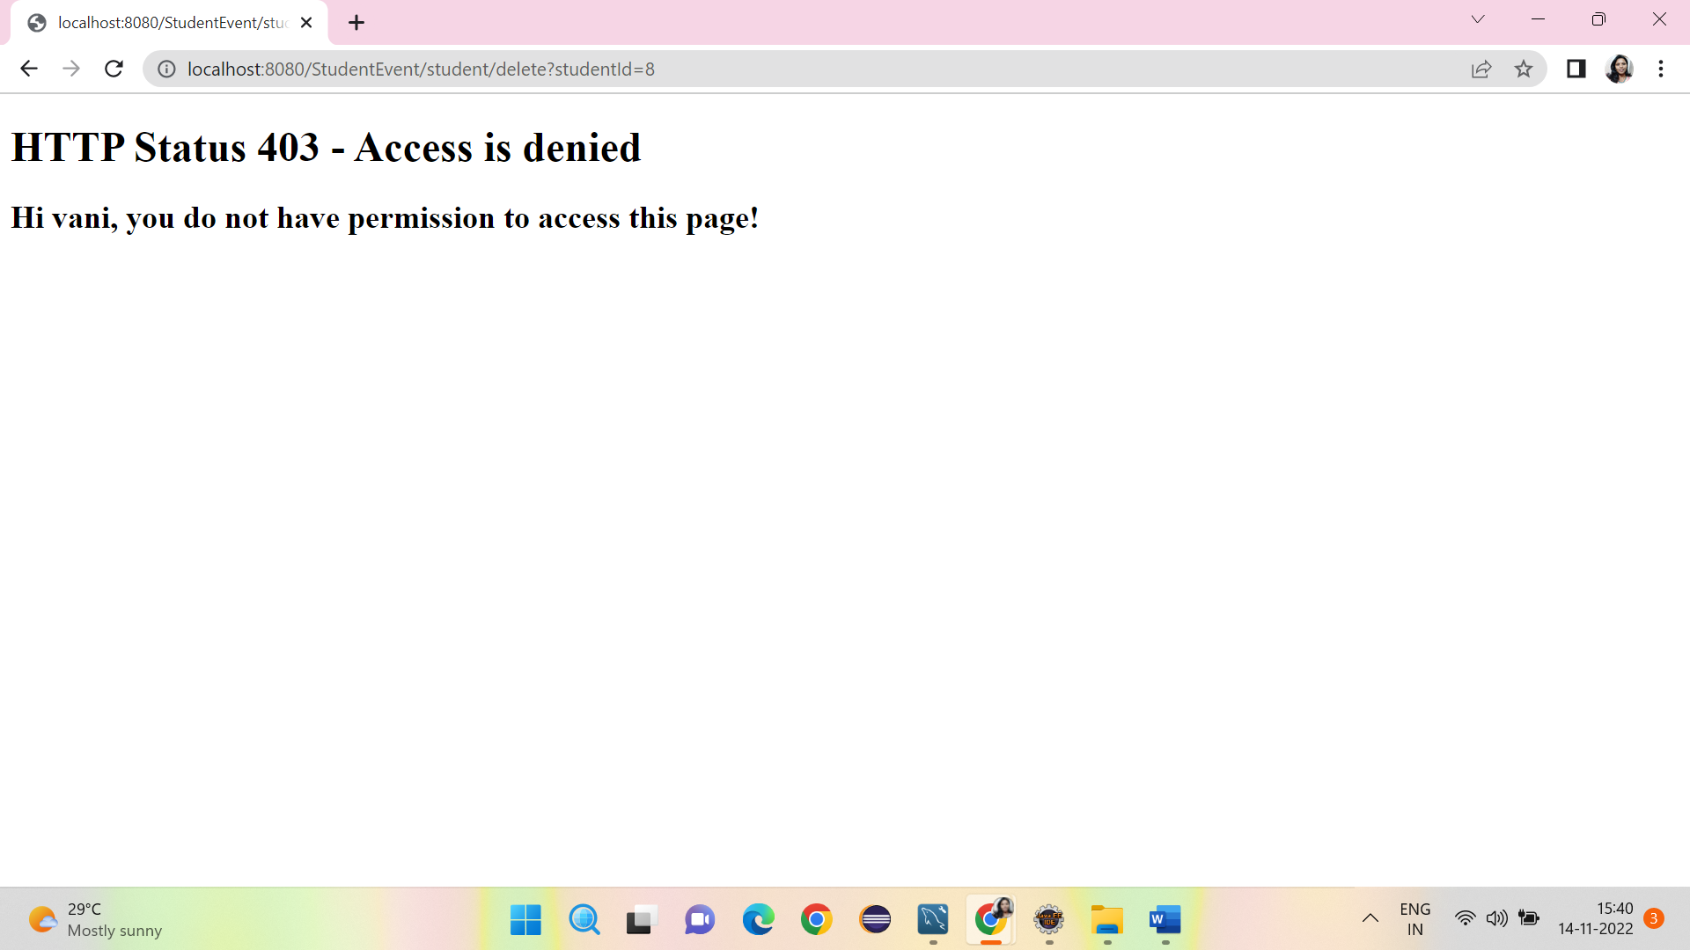

User can do ADD student
